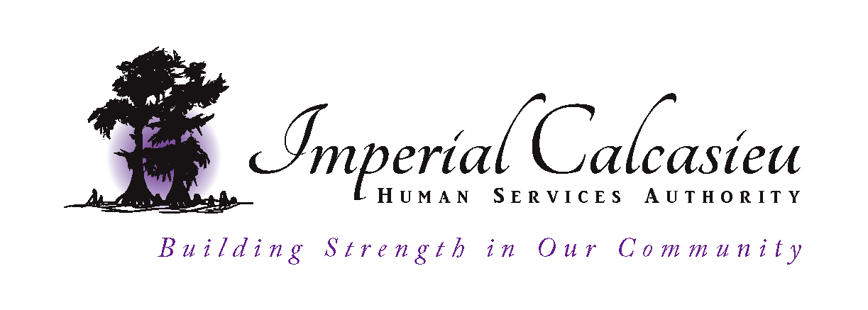
Governance Board Meeting
One Lakeshore Drive, Suite 2000
Lake Charles, Louisiana 70629
December 10, 2019

AGENDA

I. CALL TO ORDER
Corlissa Hoffoss called the meeting to order at 12:06pm noting that a quorum was
present.

II. ROLL CALL
a. Corlissa Hoffoss, appointed by Governor Jindal
b. Betty Cunningham, appointed by Governor Edwards
c. Bill Sommers, appointed by Governor Edwards
c. Linda Storer, appointed by Beauregard Parish
d. Aaron LeBoeuf, appointed by Calcasieu Parish
e. Kristen Cassidy, appointed by Jefferson Davis Parish

Absent:
Rita Cole, appointed by Allen Parish
Angela Jouett, appointed by Cameron Parish

EXECUTIVE STAFF PRESENT
a. Tanya McGee, Executive Director
b. Jenny Mills, Deputy Director
c. Leigh Conway, Human Resources Director
b. Kristen Arville, Executive Assistant

III. INTRODUCTION OF GUESTS
Corlissa Hoffoss announced no guests were present.

IV. APPROVAL OF MINUTES
Board members received November minutes prior to the meeting. Corlissa Hoffoss entertained a motion to approve November minutes. Betty Cunningham motioned and Kristen Cassidy seconded. Minutes unanimously approved.

V. APPROVAL OF AGENDA
Tanya McGee made a request to move Asset Protection to the January meeting agenda.
ImCal is utilizing a new property management software and the report produced from the new system is different from what the board is accustom to receiving. Tanya wants more time to go over the document with the property manager before she presents to the board. Linda Storer made a motion to approve the agenda with changes. Kristen Cassidy seconded.

VI. BOARD MONITORING

VII. EXECUTIVE DIRECTOR REPORT
a. Sobering and Engagement Center
Tanya McGee informed the board that the contract was signed. The Sobering and
Engagement center is open, operational, and housed at the Briscoe Treatment Center.
Odyssey House Louisiana, (OHL) is running the center and currently house six beds.
They are accepting clients that are coming to Briscoe for treatment, but need a place to
stay overnight before there is an opening on the inpatient side. This will give OHL time to work out any issues that may come up. In January the center will be open for law enforcement referrals. Tanya asked Bill Sommers how they trained law enforcement for the Multi-Agency Resource Center, MARC. Bill informed Tanya, the Office of Juvenile Justice, (OJJS) conducted trainings with officers at each shift change from both Calcasieu Parish and the Lake Charles Police Department. Tanya will proceed with same process.

b. Fiscal Move
Tanya McGee informed the board that Imperial Calcasieu, ImCal has agreed to take
over financial duties, but will stay in the state system. In order to do this ImCal will
need two additional Fiscal positions and the request has been made to the Louisiana
Department of Health in the Fiscal Year, (FY) 21 budget. If ImCal receives funding
for the two additional Fiscal positions, the plan is to make this move July 1, 2020.
This will give the Fiscal division a 3-month transition in the first quarter of the FY 21.

c. Executive Director Evaluation
Leigh Conway presented the form for the evaluation of the Executive Director to the
board. This form will monitor Tanya McGee’s work, performance and behavior. The
form will be sent to executive management staff to fill out. Responses will be sent to
Leigh Conway and she will compile the results. The board was in agreeance with the
new form. This will take place in the April meeting when the annual evaluation for the
Executive Director is due.

d. Beauregard Community Meeting
Tanya McGee asked Betty Cunningham to give an update from the Beauregard
Community meeting held on November 13th in coordination with the Office of Public
Health, OPH. Betty Cunningham stated the meeting was great and she feels that the
agencies that participated received valuable new information. ImCal and Office of
Public Health, OPH were able to inform them of their services and received valuable
feedback for correction and extension of services. Tanya McGee stated that she would
like to consider holding a public forum in each parish informing them of the services
that ImCal offers specific to the community. Tanya suggested having a rotation
of when the meetings will be held. The board was receptive to this idea.

VIII. NEW BUSINESS
Corlissa Hoffoss informed the board that if they have not completed the Ethics Trainings
that its due December 31, 2019

IX. NEXT MEETING – January 9, 2020

X. ADJOURNMENT – Corlissa Hoffoss entertained a motion to adjourn the meeting.
Linda Storer seconded. Meeting adjourned at 12:37pm.

